

**Contents**

1 Introduction, Disclaimer, Copyright, and Controls 3

2 Brush Overview

Brush Color, Size, Strength, and Density 8

Overwrite Brush 8

Additive Brush 8

Subtractive Brush 8

Filter Brush 8

Radial Brush and Radial Profiler page num

Sample Brush

Eraser page num

Standard and Custom Brush Shapes page num

Patterns and Pattern Profiler page num

3 Spline Vector Overview, Tips

Spline Mode and Width page num

Spline Colors and Filter page num

Spline Tapers and Taper Type page num

Spline Translate, Rotate, Scale, and Multiselect page num

Spline Copy, Cut, Paste, and Delete page num

4 Raster Overview

Raster Translate, Rotate, Scale, and Skew page num

Bucket and Pattern Fill page num

Raster Copy, Cut, Paste, and Delete page num

5 Layer Overview page num

Zoom, Foreground, and Background page num

Filtering Layers page num

Reordering and Compiling Layers page num

Insert Layer, Copy, Cut, Paste, and Delete page num

6 General Frame Information page num

Compile Frame into Single Layer page num

Insert, copy, cut, paste, delete

1. Importing and Exporting Images and Video page num

**Introduction**

Glass Opus is an open source rotoscoping software. for students and artists. The software will provide a variety of features that enable students and artists to develop creative works from start to finish. Drawing with a variety brushes and vectors, and image manipulation are among the many features than one can employ to create their vision.

The focus of Glass Opus, and the team behind it, is to provide a free software that students and artists can use to further their work and portfolio. This is often a difficult endeavor for artists due to the restrictive cost of major software. Since Glass Opus is open source, users can tweak features or add their own to suit specific needs. It will also serve as a foundation for those who seek to improve their knowledge in image processing and manipulation, as well as basic graphics programming.

Refer to this manual while using the software to further familiarize yourself with Glass Opus. After opening the program, importing and image or video, please refer to this user guide to understand the software. To avoid destroying created work, please read through the whole manual.

**Software Use and Liability**

The developers cannot be held liable for software and / or system crashes, progress and data loss, large file writes to the disk, or any other inconvenience caused. Upon first uses of Glass Opus, remember to check your project saves to ensure creative decisions and progress has been recorded.

**Copyright**

Glass Opus is not copyrighted. Aside for the core purpose as software for creatives, the developers intend this software as an instructional introduction or those interested in or pursing image manipulation.

**Getting started checklist**

* Make sure that the operating system running Glass Opus is up-to-date Windows 10. Unix based systems are currently not supported. Make sure the latest version of Glass Opus and C++ distribution are installed.
* If you are a developer, make sure to have the latest version of Qt, MSVC, C++ distribution, and OpenCV are installed. During development, Qt 5.13/5.15, MVSC 2017/2019 and C++ distribution 2017, and OpenCV 4.5.1 were used.

**Basic Assumptions**

* When starting the software, it can be assumed that the brush is set to size 10, spray density set to 0 (no spray), patterning off, color defaulted to black, and the brush application method to overwrite.
* Each new spline vector is set to default upon creation. This entails both spline vector colors set to black, the mode set to color vector, and its filter set to greyscale. By default, the tapers will both be zero, with the taper type being double taper.
* When starting up Glass Opus, the editing mode will default to brushing.
* Each new layer will be instantiated as a blank layer, with all pixels’ alpha value (opacity) will be set to 0, being completely transparent.
* When importing an image or video, it will be placed in the top layer of the frame.
* Exporting an image will save the current frame as an image when working with video.
* When using the color picker (eyedrop sampler) to take the color from the raster, for either the fill bucket, or the brush, the next click made after pushing the menu button will sample the color under the mouse. The color will be applied to bucket fill or the brush depending on whether you are in raster or brush mode, respectively.

**General Note**

By design and current design limitations, layer filters are not applied to the active / working layer. They are applied to layers not being worked on and to all layers during image and video export.

**1. Keyboard and Mouse Controls**

1. **Brush Mode**

* *Left* mouse press and drag applies the brush to the layer’s raster image.
* *Left* mouse click with the *shift* key held, will sample (pick) the color beneath it.
* *Right* press and drag erases the contents of the layer’s raster image.
* Mouse *wheel* spin, up or down, increases or decreases the brush size, respectively.
* Mouse *wheel* spin with the *shift* key, increases or decreases brush strength.
* Mouse *wheel* spin with the *control* key held will increase or decrease spray density.

1. **Spline Mode**

* *Left* mouse press, when over a control point, selects that control point.
* *Left* mouse drag, when a control point is selected, moves that control point.
* *Left* mouse drag, without a control point selected, moves the spline.
* *Left* mouse release, deselects the selected control point, if one is selected.
* *Right* mouse press creates a new control point, and selects it while held. Dragging the point will move the point. Release deselects the point.
* *Left* mouse press, then drag, scales the whole spline by the change in x and y.
* *Left* mouse click with the *control* key held, will select additional splines when one is at least one is already selected.
* *Left* mouse double click selects and deselects splines.
* *Right* mouse press, then drag, rotates the whole spline vector about its center.
* *Right* mouse click with the *control* key held, deselects a vector when multiple splines are selected.
* Mouse *wheel*, up or down, changes the width of the spline, respectively.
* Mouse *wheel* with the *shift* key held will increase or decrease the spline’s first taper.
* Mouse *wheel* with the *control* key held will increase or decrease the spline’s second taper.
* The *control* key, plus the c key, will copy the selected spline(s).
* The *control* key, plus the *x* key, will copy the selected spline(s).
* The *control* key, plus the *v* key, will paste any copied spline(s).
* The *control* key, plus the *delete* or *backspace* key, deletes the selected spline(s).
* The *control* key, plus the *a* key, will select all splines in the layer.

1. **Raster Mode**

* *Left* mouse press and drag, creates, and transforms the selecting area.
* *Left* mouse release finalizes the selecting area.
* *Left* mouse press with the *shift* key held, will sample (pick) the color beneath it.
* *Left* mouse press with the *control* key held, will bucket fill the area beneath.
* *Right* mouse drag with the *shift* key held will rotated the selected raster area.
* *Right* mouse press with the *control* key held will bucket fill a pattern to the area below.
* The *control* key, plus the c key, will copy the selected raster area.
* The *control* key, plus the *x* key, will copy the selected raster area.
* The *control* key, plus the *v* key, will paste the copied raster area.
* The *control* key, plus the *delete* or *backspace* key, deletes the selected raster area.
* The *control* key, plus the *a* key, will select the entire raster area.

**2. Brush Mode Details**

Brush Mode is used to draw onto the screen, by mouse, trackpad, or pen and tablet. Various of shapes, sizes, colors, filters, and effects are available under the Brush menu.

1. **Brush color** changes the color a brush applies to the image. It can be changed from the Brush menu and selecting Brush Color. This will bring up a dialog allowing the color to be changed. The color can also be changed by using the color picker tool, to select a color from the screen. By default, the brush color is black. See Figure 1.  
   The **brush size** refers to the radius of the brush, and the final diameter being two times the radius plus one. The size of the brush can be changed by navigating Brush menu, and selecting Brush Size. With a size of zero, the minimum size, only a single pixel will be drawn, with a size of one, a three-by-three area will be drawn according to the brush shape; 64 pixels is the maximum radius (129 diameter). See figure 1.

**Spray density** affects how sporadically the brush is applied on a pixel-by-pixel basis, while **brush strength** affects the intensity of the selected color. Similarly, the spray density and brush strength can be modified by selecting the respective menu items from the Brush menu. By default the spray density is 0, meaning no spray. Spraying is available for every size, shape, and application method of brush. See figure 1.

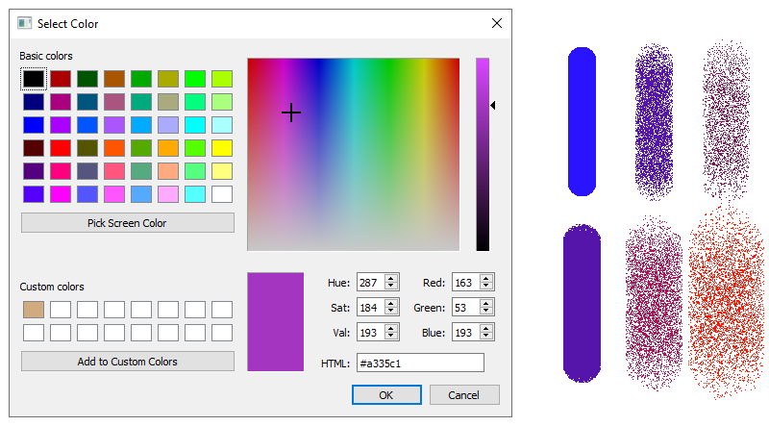

Fig 1: The color chooser dialog shown left. Spray density, color variation, and size variation featured right. Only 6 various spray densities of 128 available shown. Similarly, only 6 of 64 available radius sizes shown.

1. The **Overwrite brush** replaces the color of any pixel with the selected brush color. The overwrite brush can be used by navigating to the Brush Methods submenu, under the Brush menu, and selecting Overwrite. The radial brush can be used / applied by left pressing and dragging. See figure 3s.
2. The **Additive brush** will add the selected brush color to that of the pixels below the brush’s application area. Given that a RGB value of 255, 255, 255 (or 1.0, 1.0, 1.0) represents white, and 0, 0, 0 represents black, the Additive brush will push all colors below its application area towards white. It is important to remember when drawing on an erased area, that the other color (from the image) being merged with is white. The additive brush can be used by navigating to the Brush Methods submenu, under the Brush menu, and selecting Additive. The radial brush can be used / applied by left pressing and dragging. See figure 3.
3. The **Subtractive brush** will subtract the selected brush color from that of the pixels below the brush’s application area. Given that a RGB value of 255, 255, 255 (or 1.0, 1.0, 1.0) represents white, and 0, 0, 0 represents black, the Subtractive brush will push all colors below its application area towards black. It is important to remember when drawing on an erased area, that the other color (from the image) being merged with is white. The subtractive brush can be used by navigating to the Brush Methods submenu, under the Brush menu, and selecting Subtractive. The radial brush can be used / applied by left pressing and dragging. See figure 3.
4. The **Filter brush** will apply the chosen filter to the pixels below the brush’s application area. The filter is initially set to Normal (RGB). The filter brush can be used by navigating to the Brush Methods submenu, under the Brush menu, and selecting Filter. The radial brush can be used / applied by left pressing and dragging.  
   The **brush filter** can be changed via navigating the Brush menu and selecting the desired filter from the Brush Filter submenu. See figure 3.
5. The **Radial brush** applies a circular brush that merges the brush color with the application area according to the distance (radius) from the center of the brush. The farther out from the center of the brush, the less of the color gets merged with the application area’s respective pixel. It is important to remember when drawing on an erased area, that the other color (from the image) being merged with is white. The radial brush can be used by navigating to the Brush Methods submenu, under the Brush menu, and selecting Radial. The radial brush can be used / applied by left pressing and dragging. See figure 2.

The **Radial Profiler** allows one to profile the falloff / shape of the radial brush. The profiler provides four points of control. By default, the top left most point creates the upper limit for the height of the other points, while the bottom right point creates the lower limit of the height. The radial profiler can be accessed via the Brush menu, and navigating to the Brush Profilers submenu. See figure 2.

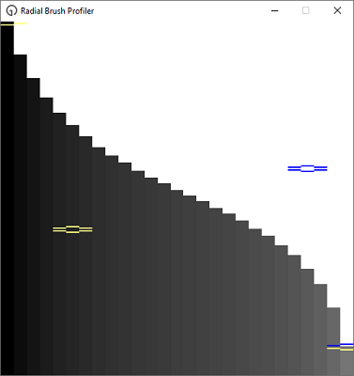

Fig 2: The Radial Profiler. By moving any of the four points, the radial brush’s falloff can be changed.

1. The **Sample brush** is used to sample from one area of the layer’s image to another, effectively copying the pixels. The sample brush can be used by navigating to the Brush Methods submenu, under the Brush menu, and selecting Sample. By right pressing and dragging, the sample point can be specified. A left press and drag allows the image around the sample point to be copied to the where the mouse is currently.

See picture below. See figure 3.



Fig 3: From left to right, Overwrite, Additive (with red brush, 50% grey canvas), Subtractive (same as Additive), Filter (Greyscale), Radial, Sample. All of radius 10.

1. The **Eraser** is used to erase the contents of the layer’s image. The erased area will display the contents of the layer underneath, as the pixel’s alpha value will be set to zero (transparent) and the color set to white. When the rearmost layer is active, the erased area will then display white. It is important to remember when drawing on an erased area with additive, subtractive, or radial brush, that the other color (from the image) being added to / subtracted from / merged with, is white. The eraser can be used / applied by right pressing and dragging when not using the sampling brush. See figure 4.

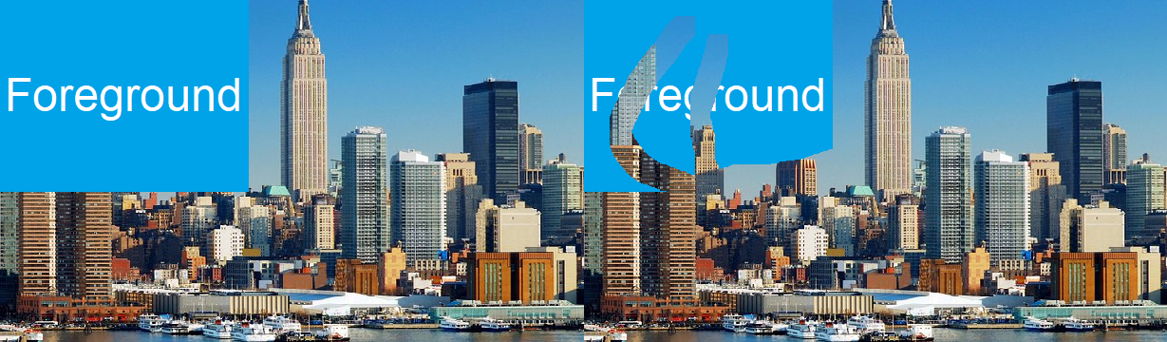

Fig 4: At left, the original image, and unerased forground. At right, the original image, and erased forground.

**Standard brushes** that come with Glass Opus are Square, Circle, Vertical (line), Horizontal (line), Left Diagonal (line), Right Diagonal (line), Diamond, and Octagon. A **custom brush** has a user specified shape. Brush shapes can be accessed by navigating to the Brush Shapes submenu, under the Brush menu, and selecting the desired shape from above. By left pressing and dragging, brush pixels are drawn in the editor, while a right press and drag erases the pixels. See figure 5.

Custom brushes can be created via the **Brush Profiler**, which provides a resizable grid on which one can draw / create a brush. Via the menu, the dimensions can be changed. The created custom brush can be used by navigating to the Brush Methods submenu, under the Brush menu, and selecting Custom. See Figure 5.



Fig 5: From left to right, Square, Circle, Vertical, Horizontal, Left Diagonal, Right Diagonal, Diamond, Octagon.

**3. Spline Vector Mode**

Spline vector mode is used to draw splines on the screen, which are lines with a variable number of curves and degrees of curvature. A spline vector can have tapers, colors, filters, as well as variable width. These can then be translated, rotated, scaled, duplicated and deleted to create the desired look. Control points are used change the curves of the spline, with more points creating more curves. There is a default minimum of two control points, creating a straight line.   
  
Tip: Rhombi can be created by applying a double taper, at max strength, and setting the spline width to that of the taper length (by eye), while using two control points. Isosceles triangles can be created by applying a single taper, at max strength, and modifying the spline width, while using two control points.

1. The **mode** of a spline vector specifies whether the spline has color(s) or filters the on area behind it in the raster image. The **width** of the spline vector specifies how wide the spline will be. See figure 6.
2. The spline’s **color** and **filter** can be utilized depending on the mode. When in color mode, the spline can have either one color, or two colors (one at each end). When two colors are used, the colors meld moving from each end of the spline towards the middle. The two colors can be swapped by selecting Swap Colors under the Vector Color submenu, within the Spline menu. The Color can be changed within that same submenu.  
   When the spline is in filter mode, it will filter the contents of the image (raster) behind it on the current layer, as well as other vectors. The filter can be specified under the Vector Filter submenu, within the Spline menu. See Figure 6.
3. **Taper Type** specifies whether there are one or two tapers on the spline. This can be changed under Taper style submenu, within Vector Taper submenu, within the Spline menu. There are 10 taper strengths (0 – 10), and each taper can be set separately under the Vector Taper submenu within the Spline menu. Regardless of the taper type, when the taper strengths are set to zero there is no taper. See figure 6.

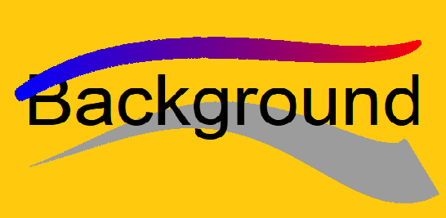

Fig 6: At the top of the image is a two-colored, double tapered, spline. Towards the bottom is a greyscale filtered spline, with only a single taper.

1. Splines can be **translated**, **rotated**, **scaled**, and **multiselected**. Translation will change any selected splines, with all control points, by some x and y. A vector can be translated by left pressing with the mouse somewhere onscreen that is not a control point, and moving to the desired point, then releasing. Vector Rotation takes place around a center point calculated as the midpoint between the lowermost bounds and uppermost bounds. The same occurs when multiple vectors are selected. Vectors can be rotated by pressing and holding the shift key, pressing and holding the right mouse button, and moving the cursor around (the center of) the vector. Scaling happens relative to the bounds, upper and lower, the vector had before scaling. Scaling allows the vector to be expanded or shrunk in the y or x direction, or both. Scaling also allows vectors to be flipped across the horizontal or vertical axis. A vector can be scaled by pressing the shift key, and moving the mouse to rescale the vector. All these features support multiselect. After an initial vector is selected, additional vectors can be selected by pressing and holding the control key, then clicking the left mouse button over a vector. During multiselect, vectors can be deselected by pressing and holding the control key, and right clicking a vector. (Pressing the shift key can be replaced by pressing any mouse button that is not left, right or the wheel, if the mouse has the buttons). See figure 7.

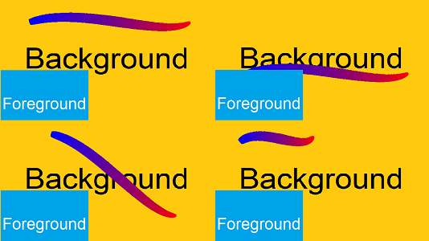

Fig 7: Top left is the original spline, with a foreground and background. Top right is a translated spline. Bottom left, is a rotated spline. Bottom right is a scaled spline.

1. A spline can be **copied**, **cut**, **pasted**, and **deleted**. Copy will duplicate the selected vectors into memory from the current layer. Delete will remove the selected vectors from the current layer. Cut will perform a copy, then delete. Paste adds these to the current layer, regardless of whether a new frame or layer has been navigated to. All these functions support multiselect. Copy can be used either via pressing and holding the control key, then pressing the C key, or using Copy via the Edit menu. Cut can be use either via pressing and holding the control key, then pressing the X key, or using Cut via the Edit menu. Paste can be use either via pressing and holding the control key, then pressing the V key, or using Paste via the Edit menu. Delete can be used either via pressing the delete key, or using Delete via the Edit menu. All layer’s vectors can be selected via the Select All in the Edit menu.

**4. Raster Edit Mode**

Raster Edit Mode allows part of a layer’s image to be selected, rotated, translated, and scaled. Additionally, an area of uniform color can be filled with another color. The fill color can be obtained from the color dialog window, or the color picker tool.

1. Image selections can be **translated**, **rotated**, and **scaled**. An image area can be selected by left pressing, moving, and releasing to define the desired area. Translation will change any selected image area by some x and y. Image rotation takes place around a center point calculated by the midpoint between the lower most bounds and uppermost bounds. Selected Image areas can be rotated by pressing and holding the shift key (or any mouse button that is not left, right or the wheel), pressing and holding the right mouse button, and moving the cursor around (the center of) the image. Scaling happens relative to the bound, upper and lower, had before scaling. Scaling allows the selected image area to be expanded or shrunk in the y or x direction, or both. Scaling also allows the selected image area to be flipped across the horizontal and/or vertical axis. A vector can be scaled by pressing and holding the shift key, (r a non-left, non-right, and non-wheel mouse button), pressing and holding the left mouse button, and moving the mouse. (Pressing the shift key can be replaced by pressing any mouse button that is not left, right or the wheel, if the mouse has the buttons). See figure 8.

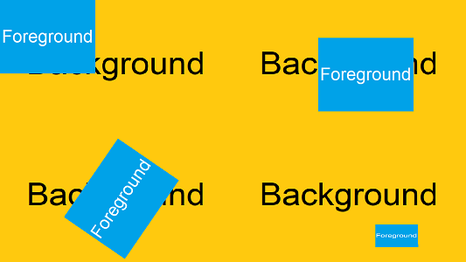

Fig 8: Top left is the original foreground and background. Top right is translated. Bottom left, is rotated. Bottom right is scaled.

1. Raster Edit Mode supports **Bucket Fill** and **Pattern Fill**. Bucket fill will replace all of a color with the new color specified by the color dialog window or the color picker tool. The color picker tool allows a color to be chosen from the layer’s image, whereas the color dialog allows a color to be chosen from a special editor. Pattern fill does the same as the Bucket Fill, except it recolors only the pixels matching the pattern. The limit to the area being filled is bounded by colors different than the mouse initially clicked. See Figure 9.

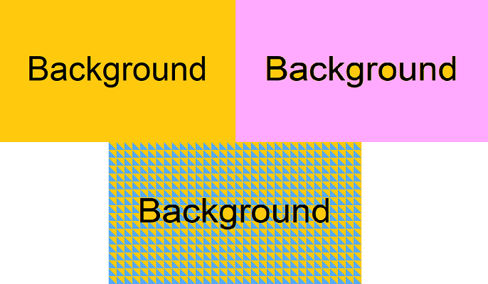

Fig 9: The top left is the original. The top right is the solid bucket fill. The bottom is the pattern fill.

1. A selected image area can be **copied**, **cut**, **pasted**, and **deleted**. Copy will copy the selected image area. Delete will remove the selected area. Cut will perform a copy, then delete. Paste will add the copied image to the current layer, regardless of whether a new frame or layer has been navigated to. Copy can be used either via pressing and holding the control key, then pressing the C key, or using Copy via the Edit menu. Cut can be use either via pressing and holding the control key, then pressing the X key, or using Cut via the edit menu. Paste can be use either via pressing and holding the control key, then pressing the V key, or using Paste via the edit menu. Delete can be use either via pressing and holding the control key, then pressing the C key, or using copy via the edit menu. The entire raster image of a layer can be selected via Select All, which can be found under the Edit menu.

**5. Layers**

Each frame comprises one or more layers. Layers are composed of imported images, brush strokes, spline vectors, and filters, and present a way to have foreground and background elements, and transparency. Layers can be navigated between via Set Active Layer in the Layer menu.

1. When viewing the layers within a frame, and finer control is needed, the layers can be zoomed in on with the **zoom** controls found under the View menu. 1/4x to 4x zoom is available, with the default (100%) being 1x zoom. Zoom In and Zoom Out control the zoom with a single click, the former increases the zoom by 3/2x and the latter decreases the zoom by 2/3x. **Foreground** and **Background** layers present a way to utilize transparency, depth, and separation of detail. Each layer behind the current working layer is a background layer, and each layer in front are foreground layers. Foreground layers can be turned off, so they are not displayed, such that the current working layer can be seen. See figure 11.
2. Layer **filters** provide a way to produce an effect on an entire layer. These include greyscale, greying (filtering) specific colors, swapping colors, inverting colors, amongst other effects. Filters can be accessed by navigating to the Layers menu, and location the desired filter from the Layer Filters menu. Filters are not visibly applied to the layer currently being working on. They are, however, applied upon export, or compiling the layer or frame. See figure 10.



Fig 10: from left to right, Normal (RGB), Greyscale (or Dull, strength 255), Polarize (strength 128), Negative, Burn (strength 40), Dodge (strength 40), Enshadow (strength 128), GRB.

1. Layers can be **reordered** withing the frame, with respect to the other layers. The current layer can be sent backwards, forwards, to the back, or to the front of the frame via the Manage Layers submenu within the Layer menu. **Compiling** a layer will render the spline vectors to the raster image the layer contains, then remove the all the layer’s vector objects. Compiling can be found under the same menu as reordering. The resulting image will look the same, and can be manipulated by the brush.

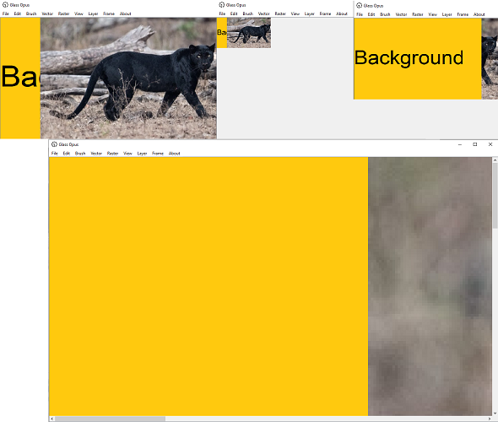

Fig 11: Top left is the original image, with background, at zoom 1.0. Top middle is zoomed out at 0.25. Top right is the layers reordered. At bottom is the original image, with background, zoomed in at 4.0.

1. New layers can be **inserted** and will default to white. Imported images and inserted layers will default to the front of the frame. New frames can be inserted via the Layer menu. Layers can also be **copied**, **cut**, **pasted**, and **deleted**. Copy will duplicate the current layer. Delete will remove the current layer; if the removed layer was the only one in the frame, the frame is removed. Cut will perform a copy, then delete. Paste will insert the layer into the front of the current frame, regardless of if another frame has been navigated to since copying / cutting. These actions can be performed only via the Insert, Copy, Cut, Paste, and Delete menu items from the Manage Layers submenu in the Layer menu.

**6. Frames**

Frames are container for the layers.

1. Frames can be **compiled**, rendering all layers down to a single layer. In this process all layers, except for the resulting layer, will be removed. To compile a frame, navigate to the Compile Frame option under the Frame menu.

**7. Import and Export**

**Importing** an image will place the image in the foremost layer of the current frame. When importing an image, various options are given to resize the image. Importing a video will place the contents of each video frame into a new layer, in separate frames. **Exporting** as an image will export the current frame. Exporting as a video will read through the project save file and exports each frame into a video file. Export formats can be specified in the export dialog window. The functions can be accessed under the File menu.

Note: Forcibly closing the application during video export or import could corrupt the video file and/or the project save file.

To be added, or if time doesn’t permit, remove text

Details uncertain

Put italics on keys mentions